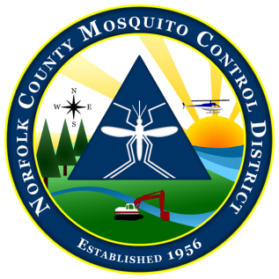
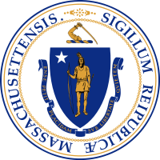

The Commonwealth of Massachusetts
The State Reclamation and Mosquito Control Board
Norfolk County Mosquito Control District
144 Production Road, Suite C, Walpole, MA 02081
(781) 762-3681 fax: (781) 769-6436
www.norfolkcountymosquito.org

Robin L. Chapell Norman P. Jacques Richard J. Pollack, PhD Linda R. Shea Kylee C. Sullivan
Commissioners

Caroline E. Haviland
Field Operations Manager
David A. Lawson
Director

Norfolk County Mosquito Control District:
Narrative Memo Highlighting Justification
of the FY 2024 Proposed Budget Request
January, 2023 update

FY 2023: The Norfolk County Mosquito Control District is proposing an FY 2024 2.5% budget increase over FY2022, to $2,166,051.

Primary factors contributing to this proposed budget increase are as follows:

- The District continues fulfilling an ongoing Fleet Management Plan that involves replacing older and high mileage vehicles each fiscal year. The Fleet Management Plan has seen the planned ongoing replacement of aging vehicles from FY 2013 through FY2022. FY 2024 may see a budgeted vehicle replacement as we plan for replacement of our Sterling transport truck. A new truck, with trade in of the Sterling, will likely cost over $128,000. We have attempted to maintain higher than ‘normal’ rollover funds to apply to this ‘one time’ larger than normal capital expense budget item. The Commonwealths new mandated EV First policy will likely see us purchasing electric vehicles in the coming years to replace older ICE vehicles, and these EV vehicles currently are significantly more expensive that ICE vehicles. A possible EV vehicle purchase could happen in FY2024.

- Employee COLA and pay increases, with the accompanying fringe costs, remain a continuing year to year cost increase. The District is currently short one FTE field technician in FY 2023, but this position should be filled before FY 2024 begins. For FY 2024, no additional hires are projected.

- Retirement costs:
The unfunded liability of the Norfolk County Retirement System (NCRS) grew substantially since 2010, principally due to the 2008/2009 financial crisis. For the NCRS to maintain the 2031 funding schedule, The NCMCD has absorbed 10% direct cost increases that continued into FY 2019. The FY 2020 retirement increase, decreased to around 6%. FY 2021 rates were a 6.6% increase over FY2020 and FY2022 is a 7% increase. FY 2023 rates are increasing by 7.26%. FY2024 Appropriation will be $232,145 which is actually a reduction from FY 2023. We are concerned that fallout from the Covid-19 pandemic and the current economic downturn may push these rates higher yet again in the near future. The current direct retirement cost to the District in FY2023 is $259,457.

- The District attempts to keep a significant rollover amount each year in anticipation of potential floodplain aerial larvicide applications and other unexpected situations. The rollover into FY2024 is currently projected to be about $160,000.

- We have been told to expect product costs to rise in response to inflationary cost increases at all levels of the supply chain.

David Lawson, Director
The Norfolk County Mosquito Control District

