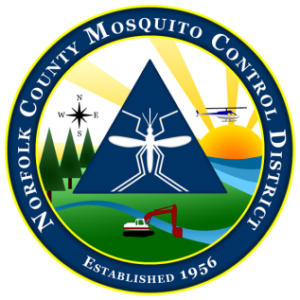
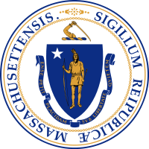

The Commonwealth of Massachusetts
The State Reclamation and Mosquito Control Board
Norfolk County Mosquito Control District
61 Endicott Street, Building #34, Norwood, MA 02062
(781) 762-3681 fax: (781) 769-6436
www.NorfolkCountyMosquito.org

Robin L. Chapell Norman P. Jacques Maureen P. MacEachern Linda R. Shea Richard J. Pollack, PhD
Commissioners

Caroline E. Haviland
Field Operations Manager
David A. Lawson
Director

Norfolk County Mosquito Control District:
Narrative Memo Highlighting Justification
of the FY 2022 Proposed Budget Increase over 2.5%.
January, 2021

FY 2022: The Norfolk County Mosquito Control District is proposing an FY 2022 3.0% budget increase over FY2021, to $2,061,678

Primary factors in this proposed budget increase are as follows.

- Operational costs have been high due to 2 main factors. 1) EEE has raised residents concern and increased requests for service, both larvicide and adulticide. This has increased use of products, of which the adult control products are quite expensive.

- The District continues fulfilling an ongoing Fleet Management Plan that involves replacing older and high mileage vehicles each fiscal year. The Fleet Management Plan has seen the replacement of 15 aging vehicles from FY 2013 through FY2020. The District replaced a dump truck, and also replaced 2 pick-up trucks with a pick-up truck and a small SUV in FY2019. FY 2021 will see replacement one of our Utility UD flatbed trucks with a Ford 350 Rack Body. FY 2022 has a planned replacement of the last old dump truck with an additional 350 dump. All of these purchases have been and may be facilitated utilizing the lease to own option from the Commonwealths Office of Vehicle Management (OVM), though we hope to move back to outright purchases in coming years.

- Employee COLA and pay increases, with the accompanying fringe costs, remain a continuing year to year cost increase. No new hires are projected for FY 2021.

- Retirement costs:
The unfunded liability of the Norfolk County Retirement System (NCRS) grew substantially since 2010, principally due to the 2008 financial crisis.
For the NCRS to maintain the 2031 funding schedule, The NCMCD has absorbed 10% direct cost increases that continued into FY 2019. The FY 2020 retirement increase, decreased to around 6%. FY 2021 rates are a 6.6% increase over FY2020. I would continue to expect rates to increase yearly at less than 10% going forward, but probably still above maintenance 2.5% levels. The Covid-19 crisis may push these rates higher again.

- The District attempts to keep a significant rollover amount each year in anticipation of potential floodplain aerial larvicide applications and other unexpected situations. The rollover into FY2022 is currently projected to be about $55,000.

- Other than minor adjustments up or down, most other expense categories will remain basically level or contain only minor estimated increases due to normal inflationary cost increases.

David Lawson, Director
The Norfolk County Mosquito Control District

