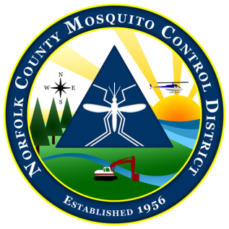
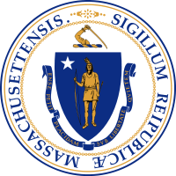

The Commonwealth of Massachusetts
The State Reclamation and Mosquito Control Board
Norfolk County Mosquito Control District
144 Production Road, Suite C, Walpole, MA 02081
(781) 762-3681 fax: (781) 769-6436
www.NorfolkCountyMosquito.org

Robin L. Chapell Norman P. Jacques Maureen P. MacEachern Linda R. Shea Richard J. Pollack, PhD
Commissioners

Caroline E. Haviland
Field Operations Manager
David A. Lawson
Director

Norfolk County Mosquito Control District:
Narrative Memo Highlighting Justification
of the FY 2020 Proposed Budget Increase over 2.5%.

FY 2020: The Norfolk County Mosquito Control District is proposing an FY 2020 6% budget increase over FY2019, to $1,933,941.

Primary factors in this proposed budget increase are as follows.

- The District headquarters moved from Norwood to Walpole in November 2017. The new lease in Walpole is about $100,000 more than what the District was paying at the Norwood Commerce Center. The District has utilized rollover funds for the last year to cover major increases, but a permanent increase in the base appropriation is needed to ‘catch up’ to this new major budget factor. This factor is basically responsible for all of the budget increase above 2.5%.

- Retirement costs: The unfunded liability of the Norfolk County Retirement System (NCRS) has grown substantially since 2010, principally due to the 2008 financial crisis. For the NCRS to maintain the 2031 funding schedule, The NCMCD has absorbed a 10% direct cost increase and will continue to budget for 10% annual increases until a new valuation dictates a change. This is a significant contribution to budget increases over 2.5%.

- The District continues fulfilling a Fleet Management Plan that involves replacing older and high mileage vehicles each fiscal year. The Fleet Management Plan has already seen the replacement of 2 of the Districts aging vehicles in FY 2013, 3 replacements in FY 2014, 2 replacements in FY 2015, 3 replacements in FY2016, and 1 in FY2017. The District did not replace any vehicles in FY2018, but has made a replacement purchase in the current FY2019. At least 1 purchase in FY2020 is planned and the District will utilize the Commonwealths option of lease-to-own which will reduce up-front costs.

- Employee COLA and pay increases, with the accompanying fringe costs, remain a continuing year to year cost increase. Fringe rates have recently increased and add to the burden. No new hires are projected.

- The District attempts to keep a significant rollover amount each year in anticipation of potential floodplain aerial larvicide applications. The rollover into FY2020 is currently projected to be about $50,000. This is low for the Directors comfort, but the plan is to build toward at least $75,000 rollovers in future years.

- Other than minor adjustments up or down, most other expense categories will remain basically level or contain only minor estimated increases due to normal inflationary cost increases.

David Lawson, Director
The Norfolk County Mosquito Control District

